

Welcome to our Summer 2024 Newsletter!


July 2024
We have only got a couple of weeks left with our school leavers, therefore we are hoping to make their remaining time with us as fun packed as possible.
The Management and staff would like to wish them all the best of luck in their new adventure at school and look forward to receiving photos of them in their uniforms.

We have a very busy month in July
Thursday 11th July some of the pre school children will be visiting Hadlum court, you will receive a permission form if your child has ben chosen to go this time.
We will be doing pictures for the elderly to take with us this next week.

GRADUATION

This is on Saturday 13th July 2024 from 11am – 1pm
This is a lovely occasion where all the children get to be with their friends and staff (some of us have known them since they were babies therefore it can be very emotional)
to celebrate their time at Cre8tive Play.


As you all know Wimbledon, football and the Tour de France are all on at the moment, so we will be doing activities relating to this like.
Playing football, tennis and riding bikes






Our Focus of the month is Dinosaurs and the ocean so we will be stomping like dinosaurs, playing with dinosaurs, drawing and painting with dinosaurs.
We shall also have lots of water play with our aquatic animals and animals that live in the sea.
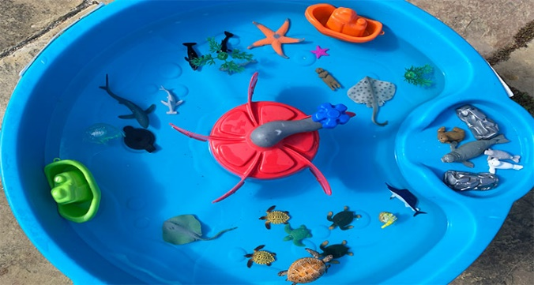
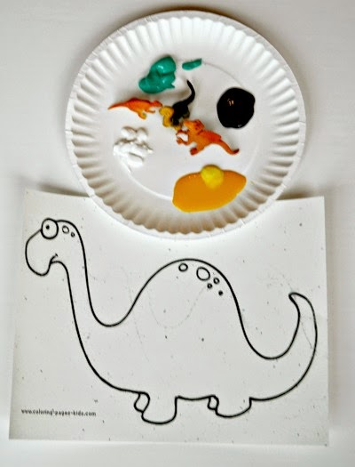


Shark awareness Day. eek!! 14th July International Tiger Day 29th




Musical Anne 2nd July
Book of the Month
Red Rockets and Rainbow Jelly
Taste of the month
Ice Cream

Important information

Last day of term for funded children is Friday 19th July 2024 and they will return Monday 2nd September 2024. If you require your child to come in during the summer holiday we are open and you will be invoiced.

Stretched funded children last day is Friday 16th August returning on Monday 2nd September 2024 The week of the 19th August is not included within the stretched funding delivery pattern. Therefore, if you do require your child to attend during this week please let us know so we can arrange an invoice to reserve a place.

We are closed W/C 26th August 2024 for maintenance, annual invoices did not include this period.

In September we have a new staff member joining our team Mrs Ida Croci. She has many years of experience and knowledge and we are excited to welcome her as part of the Cre8tive Play team.



We would like to wish the following children a happy birthday

River will be 3 on 2nd July
Henry Topping will be 2 on 29th July
Imogen will be 3 on 29th July

From all you friends and staff at cre8tive play.

STAFF HOLIDAYS
We thought it might be useful to be aware of staff annual leave for the month

Mia 3rd July
Laura 4th July
Fay 9th July
Freya 15th-19th July
Fay 19th July – 30th August
Wendy 22nd July -2nd August



August
Special Days this month

28th /7 – 1/8Caribbean Carnival
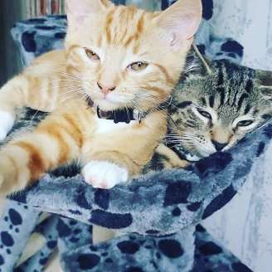
4th International Owl Day
8th International Cat day
10th World Lion day
12th World Elephant day
16th August International Tell a joke day
19th August International Orangutan Day
26th August International Dog Day

27th August International Bat Day



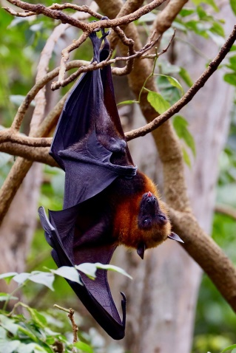



Book of the Month
Red Rockets and Rainbow Jelly
Elmer the Elephant
Taste of the Month
Strawberries
Jelly
Ice cream
Some other Activities
Making coloured jelly
Making rockets
Carnival Dressing up
Pretending to be animals and talking about them

Focus of the month

Shapes and colours in the environment




Talking about Holidays


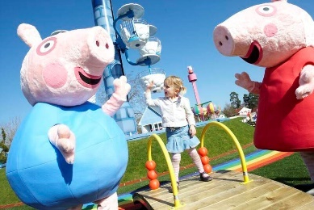

Fun at the beach & Creating our own




Aeroplanes and boats

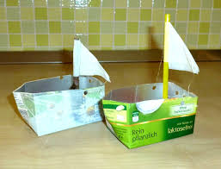

Issac will be 3 on 1st
Maeve will be 2 on 2nd
Isabel will be 1 on 11th
Emily will be 4 on 11th
Enzo will be 4 on 19th
Rosie G will be 4 on 20th
Rosie E will be 3 on 21st
Winnie will be 4 on 22nd
Hallie-Rose will be 2 on 28th



Staff Holiday
Laura 5th August-9th August
Mia 9th August -16th August
Corrina 19th August -23rd August
Nursery closed 26th August-30th August

September



Special days
The Great fire of London 2nd-6th
National read a book day 6th
World first aid day 14th
Disability awareness day 12th
Talk like a Pirate 19th

recycle week 20-26th

National fitness day 21st
World heart day 29th
Autumn 22/9-21/12



Focus of the month

Getting to know each other

Pirates


Keeping Fit



Book of the month Taste of the month
Rang-Tan in my Bedroom Ice Pops
Kiwi
Pineapple

Olive will be 4 on 2nd
Ronnie will be 4 on 7th
Henry Threadingham will be 2 on 13th
Aurora will be 1 on 17th
Evie will be 2 on 19th
Bonnie-Mai will be 1 on 23rd
Amalia will be 3 on 24th
Maximus will be 4 on 25th

Some important notices we would like to remind/ask of you

Due to safeguarding could we please ask that you don’t take your child to the toilet yourself but ask a member of staff to take them. There is often other children within the toilet area and for their privacy we ask this of you.

Could we remind you that we are a no mobile phone nursery therefore could you please not answer your phone whilst you are within the premises or make calls.

Each month we are going to have a lost property table, could you please check if any of the items are your childs.
On this topic please remember we are a pack-away nursery, therefore all childrens belongings need to be taken home daily and not left on pegs.

Spare clothes- could you please ensure that your child has spare clothes in their bags as we don’t have a supply of spares especially pre school age children. If you do borrow could you please return to the nursery.

Please remember to put on your childs suncream before they come to nursery, Factor 50 is the recommended factor for children. We will re-apply after lunch. Also named sunhats.

Please see below our medication and illness policy, this is for your convenience so that you can refer to it if you are unsure;

Medication and Illness Policy and Procedure
We promote the good health of children attending the nursery and take necessary steps to prevent the spread of infection to other children and staff. We would like to remind parents to adhere to the exclusion for illness chart below:
Temperature: Please do not send in to nursery if your child has a temperature. Also If sent home ill, child must be off for at least 24 hours.
Antibiotics: Child not allowed into nursery for the first 24 hours after first dose at home (in case of allergic reaction).
Eye Drops: Child not allowed into nursery until 24 hours (in case of allergic reaction)
Injections: Child not allowed into nursery until after 48 hours (in case of allergic reaction)
Nasal Flu Spray Children are allowed into nursery following a dose of the nasal flu spray
Vomiting & Diahorrea: 48 hours clear after last bout. Children will be sent home if they vomit or have any signs of diahorrea.
Impetigo: Allowed to return to nursery after the sores have crusted over or 48 hours after starting medication.
Operations: Children to remain at home for at least the first 48 hours in case or reaction/ risk of infection.
Covid Vaccine : If children under the age of 16 have their vaccine, they must remain at home for the first 72 hours in case of allergic reaction.
Covid: If the child has a persistent dry cough, high temperature or a lost in taste you need to keep your child at home and have them tested. If the child develops these symptoms at nursery they will be sent home and will be able return once they have the test through negatively and all symptoms have gone.
We will not accept children into the nursery who have signs or symptoms of any of the above, or if they are clearly unwell or distressed due to illness.

STAFF STRUCTURES

Management
Owner- Sharen Galvin
Managers Fay Mangion & Michelle West
Safeguarding Officers Laura Baker & Fay Mangion

SENCO- Fay Mangion,

Early Years Practitioners
Preschool
Fay Mangion – Level 3 Apprentices
Corrina Russel – Level 3 Ethan Horne
Tulin Ledwith Level 3 Freya Fellows

Toddlers
Ethan Button – Level 2 Lily Jones
Babies
Laura Baker – Level 5 Mia Parker
Beth Horne – Level 5
Wendy Lawton -Level 3
Term dates
Non Stretched Funding | 2024/2025
Come back to nursery | Finish for holiday
2nd September | 25th October
4th November | 13th December
6th Jan 2025 | ^{14th} February
^{24th} February | ^{28th} March
^{14th} April | 23th May
2nd June | 24 July TBC

Stretched Funding | 2024/2025
Come Back | Finish
2nd Sept | 20th Dec 2024
6th Jan 2025 | 19th Aug
Closed 25th august

SAFEGUARDING REMINDERS
- Unfortunately staff are unable to accept friend requests from our parents on social media, if you need to contact staff out of hours, you can email us on officecre8tiveplay@gmail.com or Faycre8tiveplay@gmail.com or you can message us direct via our parents page on Facebook
Please can we take this opportunity to remind our parents that our nursery is a mobile phone free zone, this means NO taking calls, texting and browsing the internet whilst waiting for your children. This also means that you are unable to show us photos of what your child has been up to, but please feel free to email them to us, we love seeing what they have been up to.


A FEW OTHER REMINDERS

- Please ensure that you collect your child on time as it affects our legal staff ratios. If they are collected late you will be charged £5 per 15 minutes as per your financial agreement.
- Please can you ensure that your child attends in weather appropriate clothing, such as wellies, hats, gloves during wet/cold weather with names in them and sun cream and sun hats labelled and Spare clothes are always useful too!
- Cre8tive Play t-shirts and hoodies are available for £8.50 for a hoodie and £5.50 for a t-shirt, or both for a bargain price of £13
- If you haven’t already, don’t forget to join our closed Facebook group ‘Parents of Cre8tive Play’
- Could we also ask Parents to not come into the room, unless invited as this upsets some of the other children who are not yet going home and also at the end of the day when we are cleaning we wouldn’t want to slip over.
- Can we have no nuts or nut-based products, seeded bread, pesto or nut-based chocolate spread in packed lunches, as well as no Grapes, Hola hoops, popcorn, marshmallows. This is due to allergies in the nursery and the children’s welfare means everything to us. Could baby room parents also please adhere to guidelines for the age of their child and puree

That is all for this month,From Sharen, Fay, Sue and all the staff at Cre8tive Play

