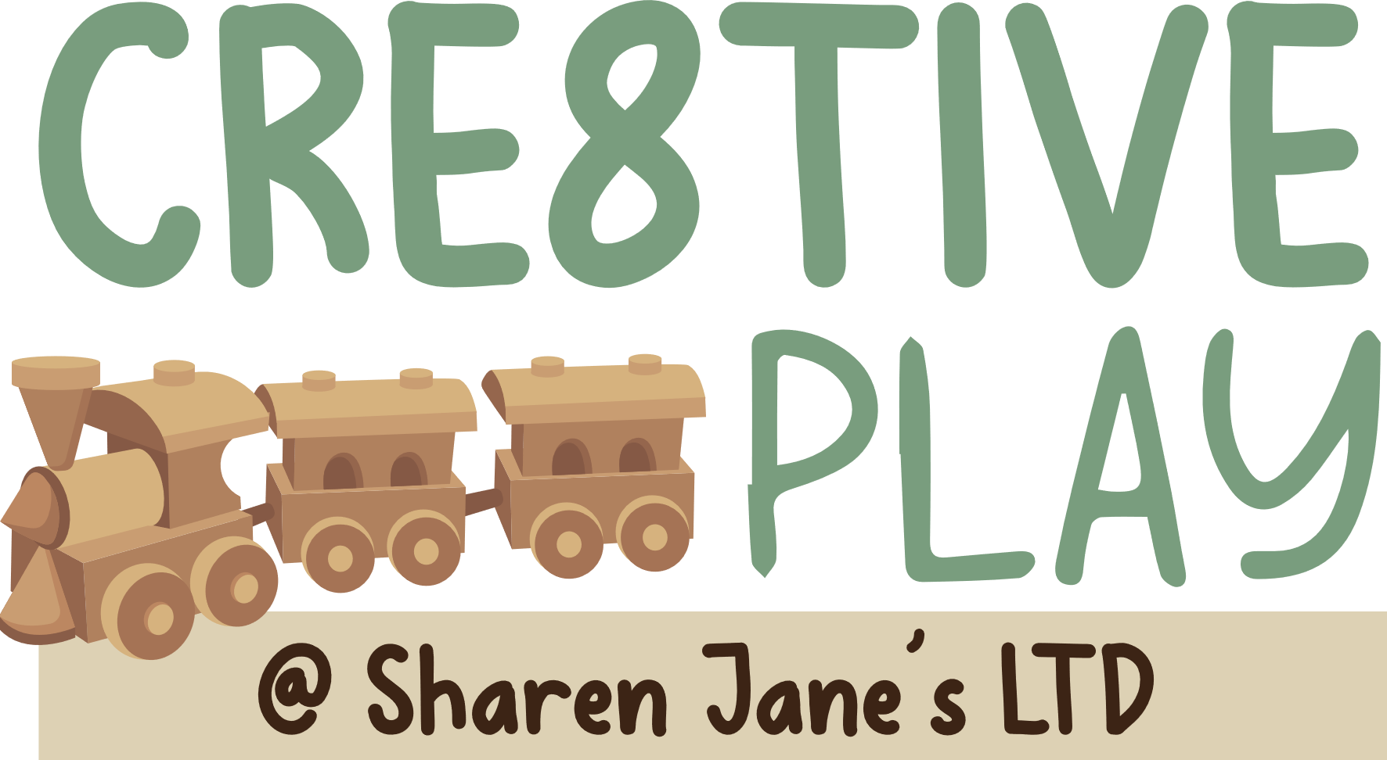 Lockdown Summary for each room
Babies
- If you have extra children in make sure you have them wrote on the white board, and up to date number of children in.
- Lockdown will be announced by a whistle and the words Moggies coming. When staff hear this, they need to shout moggies coming back.
- Babies to go behind the wall. Place as many babies into the highchairs. Member of staff to space themself out behind the wall.
- The room senior will close all windows and put the door bolts on each doors (room and kitchen door) when doing this door remember to give a call moggie coming through to preschool.
- You will need to take first aid bag, phone, and children’s water with you behind the wall.
- Move tables in the way of the doors then go behind the wall with the children.
- Make sure you head count the children when going into lockdown position and check against your room numbers.
- Keeping the children as quiet as possible, you can give them snack from the cupboard if needed.
- If a member of staff need to get in they will need to tell you the safe word or you will not open the door. If it is the police that come make sure you ask for ID or you can call 999 and find out the officers number that is dealing with the incident.
If we need to vacate the premises due to the incident, we would go to the garage and then management will contact parents when it is safe.
Toddlers
- If you have extra children in make sure you have them wrote on the white board, and up to date number of children in.
- Lockdown will be announced by a whistle and the words Moggies coming. When staff hear this they need to shout moggie coming back.
- Toddlers need to go into the green room making sure window is closed and the blind is pulled down.
- Do a head count as the children entry the lockdown room and then check against the register.
- You will need to take first aid bag, children’s water with you.
- Keep the children as quiet as possible by reminding them of the story moggies coming, encouraging them to be a little quiet mouse so the bad cat can’t find them
- The room senior will put the door bolt on the doors and move the changing station in front of the door.
- If a member of staff need to get in they will need to tell you the safe word or you will not open the door. If it is the police that come, make sure you ask for ID.
If we need to vacate the premises due to the incident, we would go to the garage and then management will contact parents when it is safe.

Preschool
- If you have extra children in make sure you have them wrote on the white board, and up to date number of children in.
- Lockdown will be announced by a whistle and the words Moggie coming. When staff hear this they need to shout moggie coming back.
- Preschool need to go into the role play room making sure window is closed and the blind in pulled down. Sit children below the shelf doing a head count and checking against the register.
- The room senior will put the door bolt on which leads to kitchen, closing windows and moving tables in front of the room we are locking down in.
- You will need to take first aid bag, phone and children’s water with you.
- If a member of staff need to get in they will need to tell you the safe word or you will not open the door. If it is the police that come, make sure you ask for ID or you can call 999 and find out the officer’s number that is dealing with the incident.
- Keep the children as quiet as possible by reminding them of the story moggies coming, encouraging them to be a little quiet mouse so the bad cat can’t find them.
- You will have a box with a parent contact details, garage key and a snack for the children.
When the lockdown is over a member of management will come round and say can you let me in whist knocking on the door. If you only hear, can you let me in DO NOT OPEN DOOR. we need to vacate the premises due to the incident we would go to the garage and then management will contact parents when it is safe.
Toilets
- Make sure you know how many children you are taking to the toilet and write it on the board.
- Lockdown will be announced by a whistle and the words Moggies coming. When staff hear this they need to shout moggie coming back.
- You will need to take the children into the utility room up by the washing machine. You will need to place the door wedge under the door.
- If a member of staff need to get in they will need to tell you the safe word or you will not open the door. If it is the police that come, make sure you ask for ID
- Keep the children as quiet as possible by reminding them of the story moggies coming, encouraging them to be a little quiet mouse so the bad cat can’t find them.
If we need to vacate the premises due to the incident we would go to the garage and then management will contact parents when it is safe.

Adapted…………………………………………………….
Management Signature………………………………………………………

