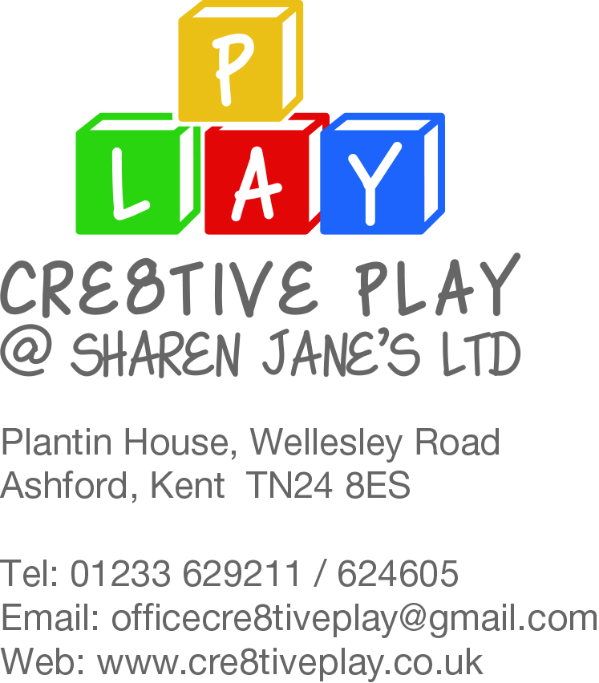
Company No: 10143781

Inclusion & Equality Policy

Cre8tiveplay @ Sharen Jane’s Ltd takes great care to treat each individual as a person in their own right, with equal rights and responsibilities to any other individual, whether they are an adult or a child. The nursery is committed to providing equality of opportunity and anti-discriminatory practice for all children and families according to their individual needs. Discrimination on the grounds of gender, age, race, religion or belief, marriage or civil partnership, disability, sexual orientation, gender reassignment, pregnancy or maternity, ethnic or national origin, or political belief has no place within this nursery.

We are aware that our building is old and therefore not completely compliant in regards of wheelchair access. Our policy is to help a wheelchair user to access the building as easily as possible, assistance would be given in regards to the stairs at the entrance and the room access as doorways are not all wide enough for wheelchair access.

Should anyone believe that this policy is not being upheld, it is their duty to report the matter to the attention of the setting manager at the earliest opportunity. The legal framework for this policy is based on:
• Equality Act 2010
• Children Act 2004
• Care Standards Act 2002
• Childcare Act 2006
• Special Educational Needs and Disability Act 2001.

Cre8tiveplay @ Sharen Jane’s Ltd and staff are committed to:
• Recruiting, selecting, training and promoting individuals on the basis of occupational skills requirements. In this respect, the nursery will ensure that no job applicant or employee will receive less favourable treatment on the grounds of age, sex, gender reassignment, disability, marriage or civil partnership, race, religion or belief, sexual orientation and pregnancy or maternity which cannot be justified as being necessary for the safe and effective performance of their work or training
• Providing a childcare place, wherever possible, for children who may have learning difficulties and/or disabilities or are deemed disadvantaged according to their individual circumstances, and the nursery’s ability to provide the necessary standard of care
• Striving to promote equal access to services and projects by taking practical steps, (wherever possible and reasonable) such as ensuring access to people with additional needs and by producing materials in relevant languages and media for all children and their families
• Providing a secure environment in which all our children can flourish and all contributions are valued
• Including and valuing the contribution of all families to our understanding of equality, inclusion and diversity
• Providing positive non-stereotypical information
• Continually improving our knowledge and understanding of issues of equality, inclusion and diversity
• Regularly reviewing, monitoring and evaluating the effectiveness of inclusive practices to ensure they promote and value diversity and difference and that the policy is effective and practices are nondiscriminatory
• Making inclusion a thread, which runs through the entirety of the nursery, for example, by encouraging positive role models through the use of toys, imaginary play and activities, promoting non- stereotypical images and language and challenging all discriminatory behaviour.

Admissions/service provision
The nursery is accessible to all children and families in the local community and further afield through a comprehensive and inclusive admissions policy. The nursery will strive to ensure that all services and projects are accessible and relevant to all groups and individuals in the community within targeted age groups.
Recruitment
All members of the selection group will be committed to the inclusive practice set out in this policy.. Application forms will not include questions that potentially discriminate against the grounds specified in the statement of intent. At interview, no questions will be posed which potentially discriminate against the grounds specified in the statement of intent. All candidates will be asked the same questions, and members of the selection group will not introduce nor use any personal knowledge of candidates acquired outside the selection process. Candidates will be given the opportunity to receive feedback on the reasons why they were not successful.
Staff
It is the policy of Cre8tiveplay @ Sharen Jane’s Ltds not to discriminate in the treatment of individuals. All staff are expected to co-operate with the implementation, monitoring and improvement of this and other policies. All staff are expected to challenge language, actions, behaviours and attitudes which are oppressive or discriminatory on the grounds as specified in this policy and recognise and celebrate other cultures and traditions.

Training
The nursery will strive towards the provision of inclusion, equality and diversity training for all staff on a regular basis. Early learning framework Early learning opportunities offered in the nursery encourage children to develop positive attitudes to people who are different from them. It encourages children to empathise with others and to begin to develop the skills of critical thinking.
We do this by:
• Making children feel valued and good about themselves
• Ensuring that all children have equal access to early learning and play opportunities
• Reflecting the widest possible range of communities in the choice of resources • Avoiding stereotypical or derogatory images in the selection of materials
• Acknowledging and celebrating a wide range of religions, beliefs and festivals
• Creating an environment of mutual respect and empathy
• Helping children to understand that discriminatory behaviour and remarks are unacceptable
• Ensuring that all early learning opportunities offered are inclusive of children with learning difficulties and/or disabilities and children from disadvantaged backgrounds
• Ensuring that children whose first language is not English have full access to the early learning opportunities and are supported in their learning.
Food
• We work in partnership with parents to ensure that the medical, cultural and dietary needs of children are met
• We will help children to learn about a range of food and cultural approaches to meal times and to respect the differences among them.

.

